Body Performance Dataset [Data Drivers]

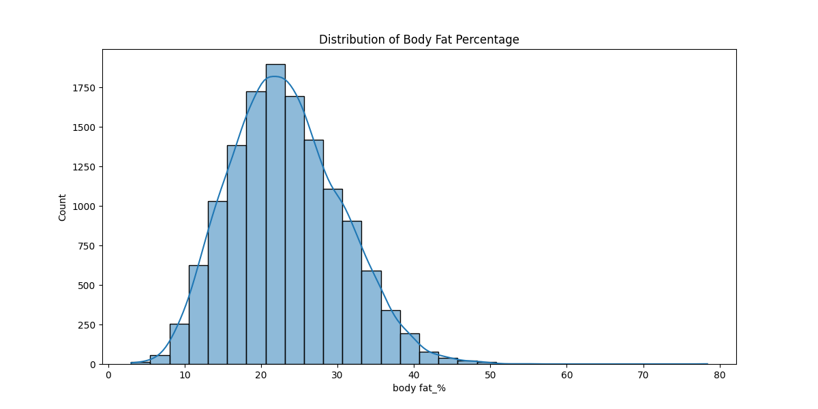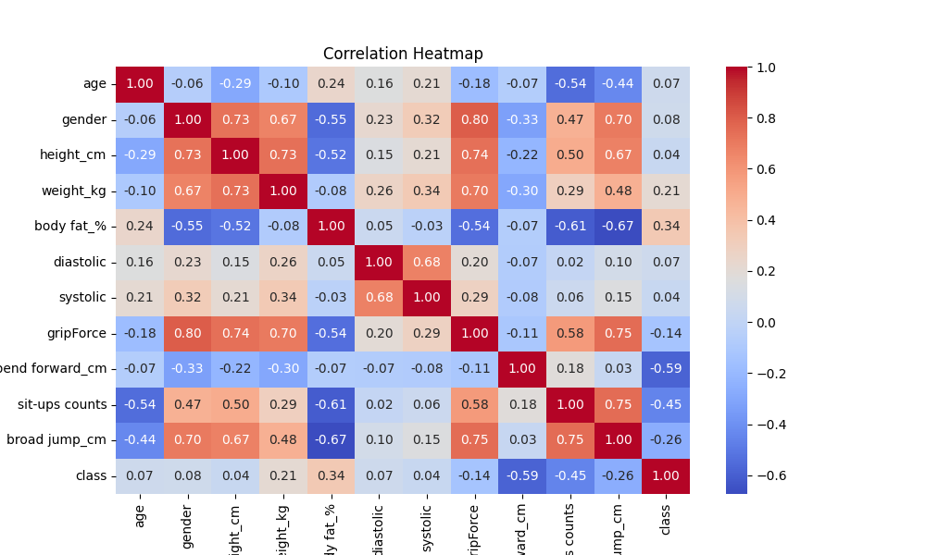

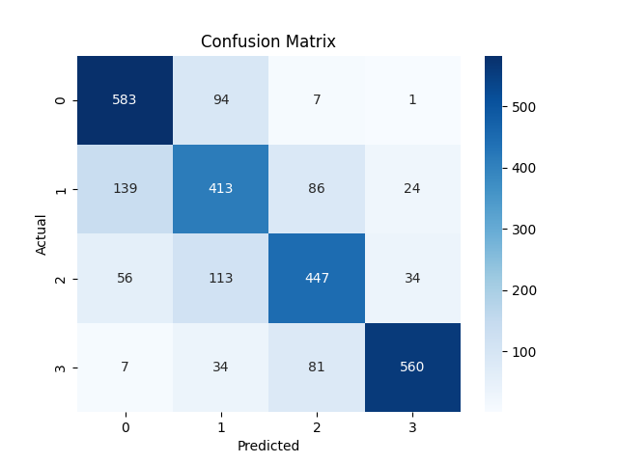

Terminal Output

RangeIndex: 13393 entries, 0 to 13392

Data columns (total 12 columns):

# Column Non-Null Count Dtype

--- ------ -------------- -----

0 age 13393 non-null int64

1 gender 13393 non-null object

2 height_cm 13393 non-null float64

3 weight_kg 13393 non-null float64

4 body fat_% 13393 non-null float64

5 diastolic 13393 non-null float64

6 systolic 13393 non-null float64

7 gripForce 13393 non-null float64

8 sit and bend forward_cm 13393 non-null float64

9 sit-ups counts 13393 non-null float64

10 broad jump_cm 13393 non-null float64

11 class 13393 non-null object

dtypes: float64(9), int64(1), object(2)

memory usage: 1.2+ MB

None

age height_cm ... sit-ups counts broad jump_cm

count 13393.000000 13393.000000 ... 13393.000000 13393.000000

mean 36.775106 168.559807 ... 39.771224 190.129627

std 13.625639 8.426583 ... 14.276698 39.868000

min 21.000000 125.000000 ... 0.000000 0.000000

25% 25.000000 162.400000 ... 30.000000 162.000000

50% 32.000000 169.200000 ... 41.000000 193.000000

75% 48.000000 174.800000 ... 50.000000 221.000000

max 64.000000 193.800000 ... 80.000000 303.000000

[8 rows x 10 columns]

Average values by gender:

age height_cm ... broad jump_cm class

gender ...

0 37.850995 160.485404 ... 153.326025 1.389363

1 36.149167 173.257399 ... 211.541526 1.564663

[2 rows x 11 columns]

T-test for grip force: t-stat = -154.39116603183484, p-value = 0.0

Accuracy: 0.7476670399402762

Classification Report:

precision recall f1-score support

0 0.74 0.85 0.79 685

1 0.63 0.62 0.63 662

2 0.72 0.69 0.70 650

3 0.90 0.82 0.86 682

accuracy 0.75 2679

macro avg 0.75 0.75 0.75 2679

weighted avg 0.75 0.75 0.75 2679  
  
  
  
# *Body Performance Prediction System - Project Report*

## *1. Project Overview*

### *1.1 Introduction*

The *Body Performance Prediction System* is a machine learning-based application designed to predict an individual's body performance category based on physiological attributes. This system utilizes various *classification models* to analyze and estimate performance levels based on factors such as age, gender, height, weight, body fat percentage, and other fitness-related measurements.

### *1.2 Objective*

The primary objective of this project is to:

- Develop a *predictive model* that can classify body performance accurately.

- Explore the *influence of different physiological features* on body performance.

- Provide a *user-friendly interface* for predictions and insights.

## *2. System Requirements*

### *2.1 Functional Requirements*

✔ Load and preprocess historical body performance dataset.

✔ Implement *feature selection and engineering* techniques.

✔ Train and evaluate *machine learning models* (e.g., Random Forest, Logistic Regression).

✔ Provide *real-time predictions* based on user input.

✔ Deploy the model using a *web application or API*.

### *2.2 Non-Functional Requirements*

✔ *Scalability:* The system should be able to handle large datasets.

✔ *Performance:* The model should provide *fast and accurate predictions*.

✔ *User-friendly UI:* A simple and interactive interface for users.

✔ *Security:* Ensure data privacy and secure API endpoints.

✔ *Cross-platform compatibility:* The application should work on *both desktop and mobile devices*.

## *3. System Architecture*

### *3.1 Architecture Diagram*

+--------------------------------------------------+

| User Interface |

| (Web App / Dashboard / API for model access) |

+--------------------------------------------------+

⬇ ⬇

+--------------------------------------------------+

| Data Preprocessing Layer |

| - Data Cleaning, Normalization, Feature Selection |

+--------------------------------------------------+

⬇ ⬇

+--------------------------------------------------+

| Machine Learning Model |

| - Model Training (Logistic Regression, SVM, |

| Random Forest, or Deep Learning Models) |

+--------------------------------------------------+

⬇ ⬇

+--------------------------------------------------+

| Model Evaluation & Optimization |

| - Performance Metrics (Accuracy, Precision, Recall) |

+--------------------------------------------------+

⬇ ⬇

+--------------------------------------------------+

| Deployment & Real-Time Predictions |

| - Flask / FastAPI Backend for Model Hosting |

| - Integration with Web App / API |

+--------------------------------------------------+

### *3.2 System Description*

1️⃣ *User Interface Layer*

- A web-based *dashboard or API* to allow users to input their details and receive predictions.

- Provides *interactive visualizations* for insights.

2️⃣ *Data Preprocessing Layer*

- *Handles missing values, outliers, and normalization* to ensure accurate predictions.

- *Feature selection* to optimize model efficiency.

3️⃣ *Machine Learning Model Layer*

- Implements *classification models* such as *Random Forest, Logistic Regression, SVM, and Neural Networks*.

- The model is trained using *labeled historical body performance data*.

4️⃣ *Model Evaluation & Optimization*

- Model performance is evaluated using *accuracy, precision, recall, and F1-score*.

- Optimization techniques such as *hyperparameter tuning and cross-validation* are applied.

5️⃣ *Deployment & Real-time Predictions*

- The trained model is deployed using *Flask/FastAPI* for real-time predictions.

- Integrated into a *web application or mobile platform*.

## *4. Technology Stack*

### *4.1 Backend Technologies*

✔ *Python* 🐍 - For data processing and machine learning.

✔ *Flask / FastAPI* - For deploying the ML model as an API.

### *4.2 Machine Learning Stack*

✔ *NumPy, Pandas* - For data preprocessing and handling.

✔ *Scikit-learn* - For implementing ML models.

✔ *TensorFlow / PyTorch* - If deep learning models are used.

✔ *Matplotlib, Seaborn* - For data visualization.

### *4.3 Frontend Technologies*

✔ *Streamlit* - For building an interactive UI.

✔ *React.js / Flask Templates* - For web-based visualization.

### *4.4 Deployment*

✔ *Docker* - For containerizing the model.

✔ *AWS / Google Cloud / Heroku* - For cloud deployment.

## *5. Implementation Plan*

| *Phase* | *Tasks* |

|------------------|----------------------------------------------------|

| 📌 *Phase 1: Data Collection & Preprocessing* | Load dataset, clean missing values, normalize data. |

| 📌 *Phase 2: Exploratory Data Analysis (EDA)* | Analyze data distribution, correlations, and key trends. |

| 📌 *Phase 3: Feature Engineering* | Select most relevant features using statistical methods. |

| 📌 *Phase 4: Model Selection & Training* | Train models (Random Forest, Logistic Regression, etc.). |

| 📌 *Phase 5: Model Evaluation & Optimization* | Fine-tune hyperparameters and improve accuracy. |

| 📌 *Phase 6: API Development* | Build Flask/FastAPI service to serve predictions. |

| 📌 *Phase 7: UI Development* | Develop a simple web dashboard for user interaction. |

| 📌 *Phase 8: Deployment* | Deploy on *AWS, Heroku, or Google Cloud*. |

## *6. Testing & Quality Assurance*

✔ *Unit Testing* – Check individual components like data preprocessing and model accuracy.

✔ *Integration Testing* – Ensure ML model integrates smoothly with API and UI.

✔ *User Testing* – Validate system performance with real-world user inputs.

✔ *Performance Testing* – Measure response time and scalability.

## *7. Deployment Plan*

✅ *Local Testing* – Run Flask API & model locally.

✅ *Containerization* – Use Docker to package dependencies.

✅ *Cloud Hosting* – Deploy on *AWS / Heroku / Google Cloud*.

✅ *CI/CD Pipeline* – Automate model updates and deployment.

## *8. Conclusion*

The *Body Performance Prediction System* provides a valuable tool for analyzing and predicting body performance based on key physiological factors. Using *machine learning techniques, this system can accurately estimate an individual's body performance and provide meaningful insights. The project successfully integrates **data preprocessing, model training, deployment, and UI development*, making it a scalable and impactful solution.

---

🔹 *Future Improvements:*

- Enhancing the dataset with additional features like exercise history, diet, and metabolic rate.

- Implementing *deep learning models* for higher accuracy.

- Deploying the system as a *mobile application* for better accessibility.

🚀 *This project showcases real-world applications of AI and machine learning in fitness and health analytics.*